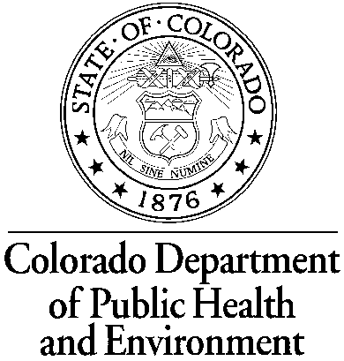
Tier 2
Drinking Water Public Notification
Certificate of Delivery Form

System Name: ___________________________________________

PWSID: CO0__________________

Reason for Notice: (description of violation or situation) ___________________________________________

Date of Violation Letter: ________________________

I hereby affirm the Public Notification for the violation or situation identified above has been provided to consumers and any consecutive water systems in accordance with the delivery, content, and format requirements of the Colorado Primary Drinking Water Regulations. I affirm that future requirements for notifying new billing units will be met. I also understand that this notice may need to be repeated in accordance with the Colorado Primary Drinking Water Regulations and I must submit this form again with each repeated notice.

Public Notice Distributed on: (date) _____________________

Check all distribution methods used to reach all consumers:
Direct delivery method (includes hand delivery and U.S. mail) – required for community water systems
Continuously posted: (list locations) _______________________________________________________
Television, Radio, and/or Newspaper: _____________________________________________________
Delivery of multiple copies to hospitals, apartment buildings, schools, or other community centers
E-mail
Other method approved by CDPHE: ______________________________________________________

List all consecutive water systems (water systems that purchase water from your system) that notice was delivered to: ______________________________________________________________________________________________________________________________________________________________________________________________________________________________

_____________________________________________________________ _____________________
Signature of owner or owner’s legal representative Date Signed

Printed name of owner or owner’s legal representative

Phone number: ______________________________________________________

Mailing Address: ______________________________________________________

Attach copies of each public notice and send to:
CDPHE
WQCD – Drinking Water CAS Or Fax to: (303) 758-1398
4300 Cherry Creek Drive South
Denver, CO 80246-1530

